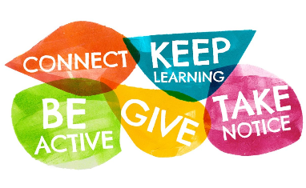
Fives Ways to Wellbeing
The evidence behind The Five Ways to Wellbeing suggests that small improvements in wellbeing result in people (and businesses) flourishing, and some mental health problems reducing.
They point to 5 clusters of small practical actions that anyone and everyone can be doing to increase the number of days that we experience as ‘good days’.
Although not easy to define precisely, a sense of wellbeing feeds feelings of happiness, curiosity, contentment, enjoyment, engagement and satisfaction. These feelings contribute to increased resilience and self-esteem and strengthen our connection with other people and the business. It forms a virtuous circle of thriving.
- You can download colourful postcards about each area
- The 5 ways can overlap, so having a lunchtime walk with a colleague is both Being Active and Connecting
- Keep interest and momentum by varying activities and ringing the changes
- Doing anything is better than doing nothing!
 | What you could do in the workplace…
Connect…  Connect with the people around you. With family, friends, colleagues and neighbours. At home, work, school or in your local community. Think of these as the cornerstones of your life and invest time in developing them. Building these connections will support and enrich you every day. | - Build in times when people can eat and talk and exercise together  - Talk with your staff, ask how they are, show interest in their lives and work.
Be Active…  Go for a walk or run. Step outside. Cycle. Play a game. Garden. Dance. Exercising makes you feel good. Most importantly, discover a physical activity you enjoy and one that suits your level of mobility and fitness. | - Encourage staff to walk or cycle to work and have a walk or run at lunchtime  - Have walking meetings  - Role model and encourage staff to walk around the office more
Take Notice…  Be curious. Catch sight of the beautiful. Remark on the unusual. Notice the changing seasons. Savour the moment, whether you are walking to work, eating lunch or talking to friends. Be aware of the world around you and what you are feeling. Reflecting on your experiences will help you appreciate what matters to you. | - Start the day by inviting/sharing what’s been good about the morning so far  - Encourage people to learn mindfulness skills  - In 1:1s invite people to talk about how they feel as well as what they have done
Keep Learning…  Try something new. Rediscover an old interest. Sign up for that course. Take on a different responsibility at work. Fix a bike. Learn to play an instrument or how to cook your favourite food. Set a challenge you will enjoy achieving. Learning new things will make you more confident as well as being fun. | - Ask people to reflect on what they have learned as much as what they have achieved  - Encourage curiosity and experimenting  - Promote learning and training in all forms - listening TED talks as well as formal courses
Give…  Do something nice for a friend, or a stranger. Thank someone. Smile. Volunteer your time. Join a community group. Look out, as well as in. Seeing yourself, and your happiness, linked to the wider community can be incredibly rewarding and creates connections with the people around you | - Offer people a little time – listen, ask  - Have charity days  - Encourage some community volunteering – maybe in work time or as a Team AwayDay

