Guidance
This tool is provided to help professionals explore neglect with families in an accessible format.
This PDF is accessible on laptops/devices or it can be printed. Overview sheet (page 2):
Provides an overview of key themes when exploring neglect of children.
There is the potential to print and cut them out to make into cards. A blank card is offered to prompt exploration of additional themes.

Theme sheets (pages 3-14):
Theme sheets provide pick and mix examples you can use to guide discussions with families. They do not provide an exhaustive list.
Not all themes will be relevant to all families. They will need to be adapted depending on the audience, age, needs of the child and focus of discussions.
Wording may not be accessible. Ambiguous terms and assumed knowledge needs to be fully explored with families to ensure there is a shared understanding.
Where possible language is strength based and avoids a deficit led approach.
A blank sheet is provided to support development of additional themes and/or active participation of families in discussions.
With thanks to Hampshire Safeguarding Children Partnership for this resource.

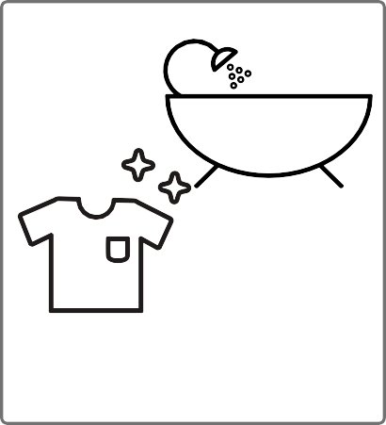

Food

Hygiene

Housing
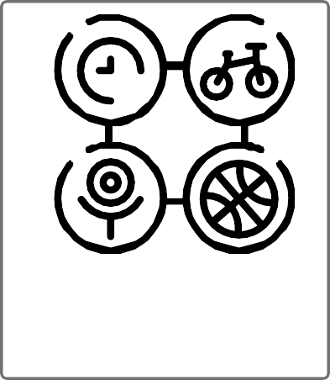

Warmth, Care & Love

Health Care

Boundaries

Supervision

Positive Values

Safety

Play & Activities

Education

...meal routines as a
...good quality food - not all
...parents/carers who know
needs met.
...enough food - so they are

family.

not hungry or overfed.

...special dietary
food is important.
sweets or 'junk' foods.

Food
...encouragement to
...parents/carers to take an
interest in their appearance.
...skin conditions to be treated
e.g. nappy rash.
...clean clothes.
... to wash daily with parent/

brush teeth.
carer support and

encouragement.

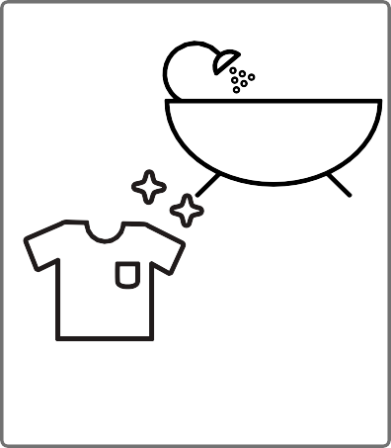

Hygiene

...hygienic facilities in a
essentials e.g. for cooking,

...stability in home

conditions e.g. in those

reasonable state of

that live at the address.
repair.

sleeping.
heating, washing and
... a home that provides
...animals to be well cared for
and who don't pose a risk to
them.
...a stable home without
unnecessary moves

Housing

needs and
are consistently responsive

... parent/carers who are concerned and interested in their
... to make a contribution
welfare and needs.
to some household tasks
that are age and stage
appropriate.

… to be left in the care of
'suitable' adults.
to their needs.
... adults/carers who
… understanding of their
best interests.

Warmth, Care & Love
...encouragement to
and accept medical
support/advice when
appointments, including
preventive care e.g. dental
check-ups and
immunisations.
... support to complete any
prescribed medications or
treatments.

...parent/carers who seek

required.

... support to attend health
brush teeth.

Health Care

Boundaries
... appropriate discipline and
sanctions. No physical
chastisement or other forms of
harsh discipline.
… protection and guidance on
safe relationships and forms
of risky behaviour.
… consistency
... their whereabouts to be known.
Including parents/carers taking action
when they don't return home at a
reasonable time or at all.
... their whereabouts to be known.
Including parents/carers taking action
when they don't return home at a
reasonable time or at all.
… appropriate supervision in
… monitoring, controls and

… parents/carers who will

intervene when there
guidance on the use of

is imminent danger.
technology including social

media.

… to be attended and responded to.
development.
line with age and level of
adults.
… to be left in the
care of 'suitable'

Supervision
… parents/carers who don't misuse
alcohol or drugs and who avoid
smoking in the house.
… parents/carers that
encourages positive values,
e.g. that anti social behaviour
is not acceptable.
… parent/carers who don't discuss the
impact of their feelings of low mood/
depression in front of them or hold child
responsible for them.

Positive Values

… parents/carers

who provide advice

and support.

media.
… monitoring, controls and
guidance on the use of
technology including social
supervision.
… safe handling and
… taught traffic
safety skills.
equipment.
… Consistent
boundaries
on the child.

Safety
… parents/carers who do not
argue aggressively or
engage in domestic abuse
and understand the impact
… protection and guidance on
forms of risky behaviour.
… parents/carers who are
aware of safety issues, seek
advise and use safety

… opportunities for activities/
understand and address any
bullying behaviours.
supported and encouraged by
of stimulation.
toys/ games appropriate
…
to age and development.

… friendships which are

parents/carers.

outings.

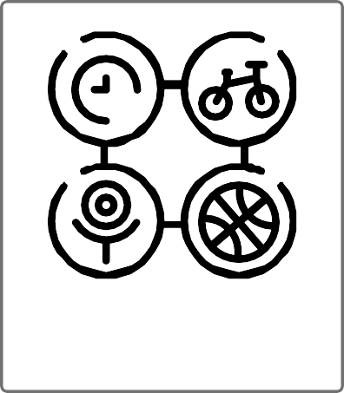
… parents/carers who
… good levels

Play & Activities

… parents/carers who take
an active interest in
schooling and homework.
encouragement and
…
support with attendance.
… parents/carers who value
school and other educational
opportunities .

Education

